[Rhobius’ Guide To The STEEK!]
(Super Totally Electrically Efficient Killer) Certified by the King C.H.U.D. himself!*
So you thought it was a good idea to take that 3 foot Xbox-to-USB adapter and connect your Mega Jockey 9000 to your PC, but found that it does NOTHING?!
You aren’t alone, and this guide helps to solve that, and throw you down a pit of pain!
NOTE: This guide only works on Vista, 7, 8 and 10!
WARNING: You’re going to require a 3 foot Xbox-to-USB adapter cable. You can find these on sites like eBay, Amazon or Aliexpress. Buy the cheapest one available.
Q: Why 3 feet? What if I wanna play from another room?
A: The cable for the MJ9K is already long enough, and 6 feet
cables will not provide enough power for the controller to work.
Once you have obtained it, you can now continue with this guide.
[This is a link to a .ZIP file with everything you need included.]
Step 0) Enable test signing mode, or nothing will work! This is important not only for vJoy and LibUSB installing (the driver will NOT install if TS is off!).
Remember: Test Signing can be turned off once the controller is confirmed to turn on and work. All of this will keep working regardless afterward.
Step 1) Install vJoy 2.1.9. Do note that whenever you
want to play with the MJ9K, you’ll have to enable test-signing
mode and restart, as vJoy’s drivers are not digitally signed.
Setup the installer like this when it asks you to.
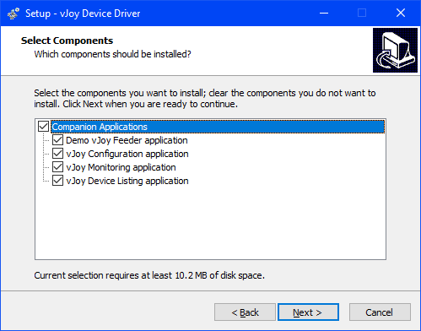
After this, open your Start Menu and find the vJoy folder, then open “Configure vJoy” and configure your controller exactly like this. Tick ‘Enable vJoy’ and Apply.
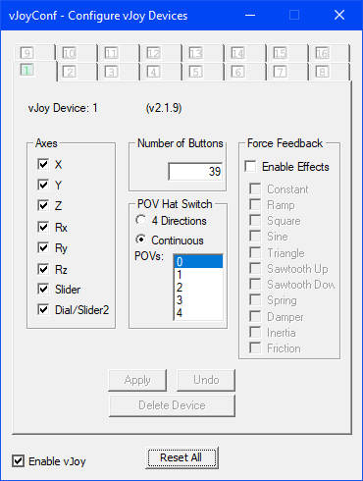
Step 2) After that, install LibUSBDotNet using the setup from here. Do not enable anything regarding installing a ‘filter’ as it causes problems. All you need is the driver.
Step 3) You’re going to need the Steel-Battalion-64 driver package, included in the zip file. Just run the .exe file. If you did the previous two steps correctly and selected the ‘STEEK.cs’ file using the File tab, the controller should flash 5 times.
Ignore any errors about vJoy, they do not matter.
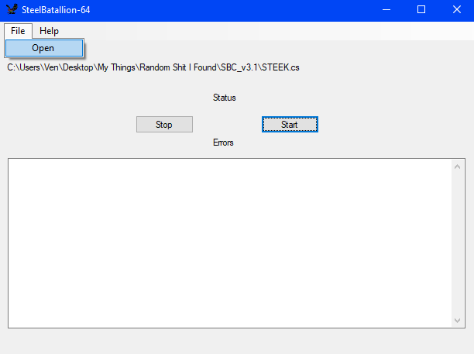
After this, you should have a working 39 button controller with 8 axes in the game controllers panel that you can open with Device Manager or search for it in Windows.
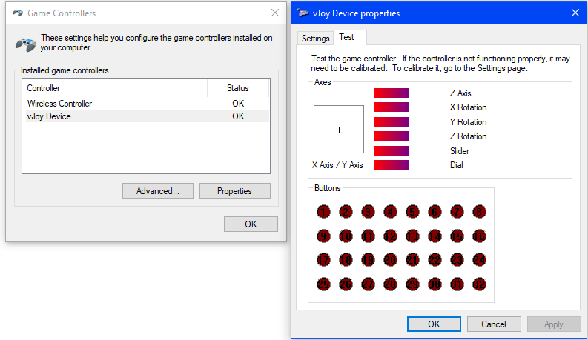
Do not bother calibrating, unless you genuinely need to. Calibrating when you don’t need to is going to cause issues with axes being in the wrong place even with the controller in neutral (not the gear, neutral as in ‘no input’).
With that said and done, you now have a working 39 button DirectInput controller. Now, how do you turn it into something normal, in case the game you’re playing doesn’t support it? Use joy2key or Xpadder (Xpadder only sees 32 buttons, so you’ll be missing Comm5, Toggles and Sight Change Click) to map keyboard buttons onto the controller, and XOutput to turn the controller into a standard X360 controller (you can only bind as many buttons as the 360 controller has). Happy playing!
By the way: Thanks to TheBestMasta for the original guide.
*Not actually certified by the King C.H.U.D as he was too busy
eating the paper instead of writing on it.

